Operational Concept Description (OCD)

The Los Angeles Community Garden Inventory and Locator

Team 13

Ardalan Yousefi Project Manager
Cole Cecil Integrated Independent Verification & Validation
Jeff Tonkovich Implementer
Shi-Xuan Zeng (Gary) Tester

April 26, 2012

Version History
Date | Author | Version | Changes made | Rationale
09/19/2011 | Larry | 0.1 | - Update section 3.1 | - Initial draft for use with CSCI 577a
09/21/2011 | Pei-Chen | 0.2 | - Update chapter 1 and 2 | - Initial information of current system
09/22/2011 | Matt | 0.3 | - Update of benefit chain | - New version of the benefit chain
09/23/2011 | Pei-Chen | 0.4 | - Correct index for tables and figures | - Consistent format
09/23/2011 | Larry | 0.5 | - Update table 3.1 | - Fix the current business workflow diagram
10/04/2011 | Pei-Chen | 1.0 | - Correct terminology inconsistency  - Update of benefit chain  - Update section 3.2, 3.3 and 3.4 | - Consistent terminology for database manager  - Fix ambiguous descriptions in benefit chain diagram  - Initial draft of new system
10/07/2011 | Pei-Chen | 1.1 | - Update benefit chain, system boundary diagram and business workflow diagram  - Update section 2.2 and 2.3  - Correct document format | - Fix benefit chain, system boundary diagram and business workflow diagram from TA’s note  - Synchronize data from Winbook  - Consistent format
10/13/2011 | Pei-Chen | 1.2 | - Update benefit chain, current business workflow, new business workflow and ER diagram  - Update section 3.2.2, 3.2.5, 3.4.1 and 3.4.2 | - Fix diagrams from TA’s note and Cole’s comment.  - Fix bugs from Cole’s comment.
10/14/2011 | Pei-Chen | 1.3 | - Update benefit chain, current business workflow, new business workflow and ER diagram  - Update section 3.2.1 and 3.2.4 | - Fix diagrams from team discussion and TA’s note  - Add new capability goals and constrain
10/16/2011 | Pei-Chen | 1.4 | - Update section 1.2  - Update section 3.2.1 | - Change the status of OCD  - Synchronize with SSRD
10/20/2011 | Pei-Chen | 1.5 | - Update benefit chain, current business workflow, new business workflow and ER diagram | - Fix diagrams from TA’s feedback
10/24/2011 | Pei-Chen | 2.0 | - Update system boundary diagram | - Feedback from ARB, added Google Map to the diagram
11/04/2011 | Pei-Chen | 2.1 | - Fix the system boundary diagram  - Update section 1.2 | - Remove PHP in the diagram  - Update the status of OCD
11/13/2011 | Pei-Chen | 2.2 | - Update benefit chain and ER diagram | - Fix diagrams from TA’s feedback
11/21/2011 | Pei-Chen | 3.0 | - Update system boundary diagram and OCD status | - Add EPPlus into system boundary and change status of OCD
11/21/2011 | Pei-Chen | 3.1 | - Update system boundary diagram and OCD status | - Add iText into system boundary and change status of OCD
02/02/2012 | Ardalan | 3.2 | - Removed PHP from Table 5 | - IIV&V’s comment
02/05/2012 | Jeff | 4.0 | - Update Section 3.2.2 | - Added new LoS goal
02/13/2012 | Jeff | 4.1 | - Updated version | - Updated for final RDCP
03/24/2012 | Jeff | 5.0 | - Remade Figure 2 | - Added AjaxControlToolkit
04/08/2012 | Jeff | 5.1 | - Updated Table 1, Figures 2 & 4 | - Added Database Viewer role to system per Client feedback
04/10/2012 | Jeff | 5.2 | - Updated Figure 2 | - Typo: missing database viewer
04/15/2012 | Jeff | 6.0 | - Version Update | - Version update for TS Set
04/26/2012 | Jeff | 7.0 | - Updated Table of Contents | - Final Release

Table of Contents
Operational Concept Description (OCD) i
Version History ii
Table of Contents iv
Table of Tables v
Table of Figures vi
1. Introduction 1
1.1 Purpose of the OCD 1
1.2 Status of the OCD 1
2. Shared Vision 2
2.1 Success-Critical Stakeholders 2
2.2 System Capability Description 2
2.3 Expected Benefits 3
2.4 Benefits Chain 4
2.5 System Boundary and Environment 5
3. System Transformation 6
3.1 Information on Current System 6
3.2 System Objectives, Constraints and Priorities 8
3.3 Proposed New Operational Concept 10
3.4 Organizational and Operational Implications 12

Table of Tables
Table 1: Success-Critical Stakeholders 2
Table 2: System Related Artifacts 6
Table 3: Capability Goals 8
Table 4: Level of Service Goals 8
Table 5: Relation to Current System 9

Table of Figures
Figure 1: Benefits Chain Diagram of the Los Angeles Community Garden Inventory and Locator 4
Figure 2: System Boundary and Environment Diagram of the Los Angeles Community Garden Inventory and Locator 5
Figure 3: Current Business Workflow of Los Angeles Community Gardens Inventory and Locator 7
Figure 4: Element Relationship Diagram of Los Angeles Community Gardens Inventory and Locator 10
Figure 5: New Business Workflow of Los Angeles Community Gardens Inventory and Locator 11

Introduction

Purpose of the OCD

This document provides, in detail, the shared visions and goals of the stakeholders of the Los Angeles Community Garden Inventory and Locator for Los Angeles Neighborhood Land Trust (LANLT). The success-critical stakeholders of the project are LANLT, as the project owner; Dore Burry, as authorized representative for LANLT and future database manager; the USC development team, as developer. Los Angeles Community Gardening Council (LACGC), Los Angeles Neighborhood Land Trust (LANLT), UCCE, LACC, as database manager in charge of updating newest information of community gardens.

Status of the OCD

This is the final version of the OCD (version 7.0) and is included as part of the Transition sub-phase of the Development phase. No significant changes since the last version.

Shared Vision

Success-Critical Stakeholders
Table 1: Success-Critical Stakeholders
Stakeholder | Authorized Representatives | Organization | Relation to Benefits Chain
Client | Dore Burry | Los Angeles Neighborhood Land Trust (LANLT) | - Provide information and feedback to the development team.  - Provide training to the other database managers.
Development  Team | Ardalan Yousefi as project manager | University of Southern California (USC) | - Develop new system  - Provide training to client of using the system.
Database Manager | N/A: Applies to anyone in LACGC, LANLT, UCCE and LACC who has the right to update current data. | Los Angeles Community Gardening Council (LACGC), Los Angeles Neighborhood Land Trust (LANLT),  University of California Cooperative Extension (UCCE), Los Angeles Conservation Corp (LACC) | - Provide update information and spread out to end-users
Database Viewer | N/A: Applies to anyone in LACGC, LANLT, UCCE and LACC who has the read-only access to the current data. | Various researchers / personnel within the organizations listed for Database Manager who do not need or are not given edit-level access to the database. | - Retrieve the newest information from the database for carrying out research / other organizational tasks.
End-user | N/A: Applies to anyone who may use the system. | N/A | - Retrieve the newest information of all the community gardens

System Capability Description
- This project is a web-based system that provides information about community gardens.
- The target customers for the system include LANLT, LACGC, UCCE and LACC as of information providers to improve the service of community gardens.
- The system will help end-users to retrieve up-to-date information about nearby community gardens.
- The common service for now is LACGC website which provides location information of all community gardens, but some of the information is out-of-date and hard to update new information through current system.
- The new system for LANLT will provide up-to-date information about all the community gardens for end-users and have an easy-to-use interface for database managers to update new information into the web-based system.

Expected Benefits
- The new system will provide an up-to-date, accurate, and complete assessment of resources available to students, youth, elderly, and others who might be interested in volunteering at or learning more about community gardens.
- The new system will provide fundraising assistance to the individual gardens by making their work known, and by allowing larger organizations to proactively seek funding on behalf of the gardens.
- The new system will increase efficiency of the entire process, from updating information to making it available to constituents. It will also make it easier to handle requests and questions.
- The new system will provide public health benefits by getting people involved in outdoor activities and promoting gardens that disseminate information to the public.
- The system will help tracking of city assets and community assets more accurately.

Benefits Chain
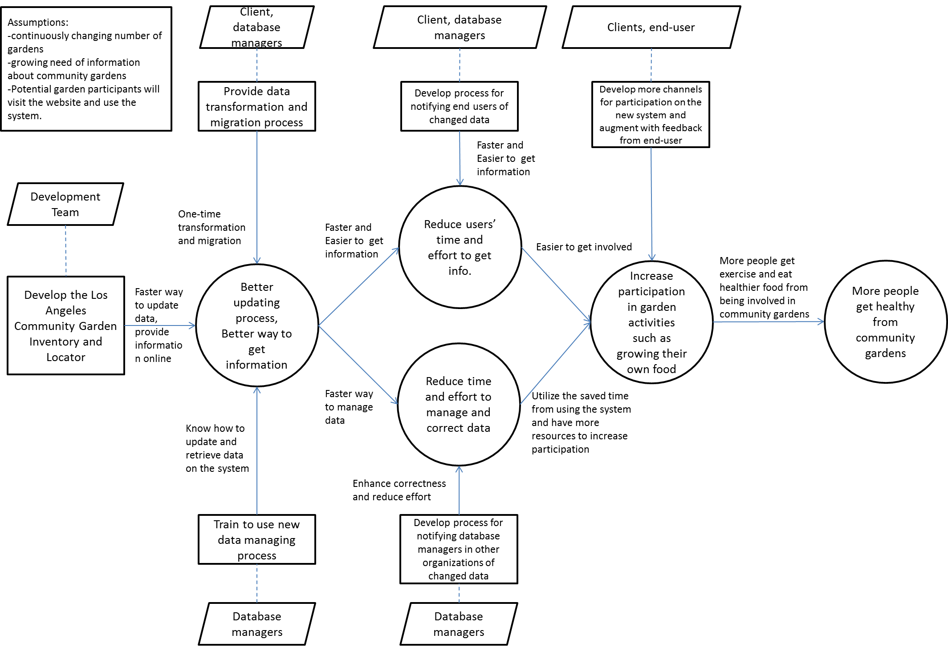
Figure 1: Benefits Chain Diagram of the Los Angeles Community Garden Inventory and Locator

System Boundary and Environment
The figure below shows the basic structure context diagram used to define the system boundary.

End-Users

Database Managers

Administrator

Internet

Google Maps
-Garden Management System
-Garden Locator
-Reporting System
-User Management System
Support Infrastructure
-ASP.NET 4.0
-AjaxControlToolkit
-SQL Server 2008
-JavaScript
-iTextPlus
-EPPlus

Database Viewers
Figure 2: System Boundary and Environment Diagram of the Los Angeles Community Garden Inventory and Locator

System Transformation

Information on Current System

Infrastructure
The client’s organization, LANLT, has a website hosted by Cbeyond. The hosting package includes Free BSD operating system, Apache web server, MySQL database, and PHP scripting. The organization itself does not have dedicated server or IT department for the planned system.
LANLT’s website does not host the community garden information but rather another organization, LACGC, hosts the community garden information with Google Map, with outdated data.
LANLT will take over the responsibility of hosting the community garden information, in PDF/Google Map format on its website in fall of 2011 with updated data.

Artifacts
Table 2: System Related Artifacts
Artifact | Description
LACGC website | Contains the current implementation of community garden map
LANLT website | Contains the future home for the community garden map, and possible host to the planned system
Community Garden Inventory Worksheet | The list of updated community garden information
Community Garden Columns Spreadsheet | The list of columns for the community garden information, and possible database for the planned system
LANLT Proposal | The initial client proposal for the planned system
A Guide to Los Angeles’ Community Gardens PDF | The list of updated community garden information in PDF format that will be updated through the development of the planned system until the system is up and running
Community Garden Google Map | The Google Map list of the community garden information
LA Gardens: Mapping to Support a Municipal Strategy for Community Gardens Report | A study done by USC GIS group about Los Angeles county population with its relationship between green space, demographics, and social welfare.
LANLT webhost package | Contains the web hosting package that might be used for the planned system

Current Business Workflow

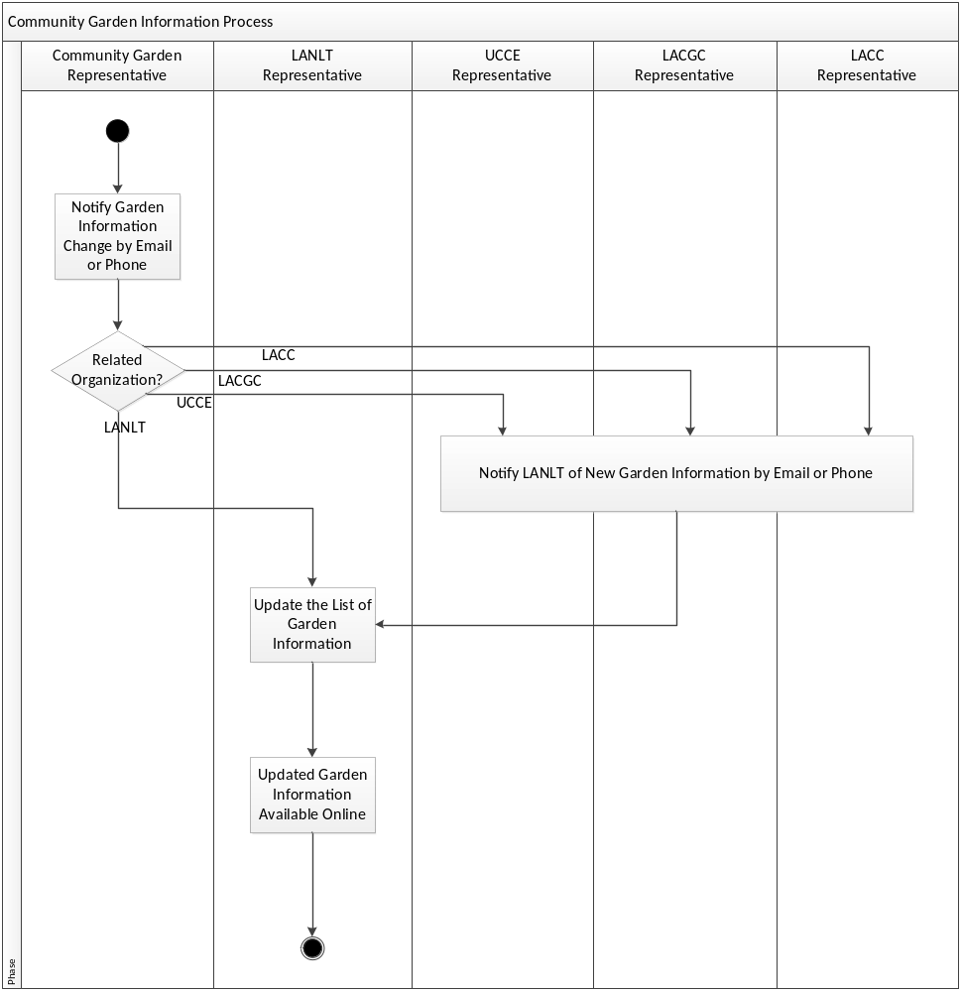
Figure 3: Current Business Workflow of Los Angeles Community Gardens Inventory and Locator

System Objectives, Constraints and Priorities

Capability Goals
Table 3: Capability Goals
Capability Goals | Priority Level
OC-1 Community Garden Map Locator: The system is capable of providing geographical information of community gardens through Google map. | Must have
OC-2 Database Management: The system is capable of providing database managers and administrator a web interface to update and manage data in the database. | Must have
OC-3 User Management: The system is capable of providing administrator a web interface to manage the accounts of database managers. | Must have
OC-4 Report Generation: The system is capable of generating report for database managers and administrator. | Must have
OC-5 End-user Information Retrieving: The system is capable of providing end-users information of community garden such as list of all gardens and phone number of gardens. | Must have
OC-6 Secure Login: The system is capable of providing a login page for database managers and administrator. | Must have
OC-7 Garden Search: The system is capable of providing database managers and administrator abilities to search specific garden they need. | Must have

Level of Service Goals
Table 4: Level of Service Goals
Level of Service Goals | Priority Level
LOS-1: System Response Time: System should respond to any user action within 10 second and render the required page. | Should have
LOS-2: System Security: The system should pass external testing for SQL injection attacks. | Should have

Organizational Goals

OG-1: Reduce cost from hiring IT professionals to maintain the data in the system via web-interface database management system.
OG-2: Reduce time and effort for LANLT, LACGC, UCCE and LACC to collect and manage information of community gardens via central database management system.
OG-3: Reduce time and effort for end-users to get information via faster information update process.
OG-4: Increase participation in community gardens via the new Los Angeles community garden inventory and locator.

Constraints

CO-1: Limited Budget: The cost for new system must be less than $1000.

Relation to Current System
Table 5: Relation to Current System
Capabilities | Current System | New System
Roles and Responsibilities | Only Los Angeles Neighborhood Land Trust (LANLT) has information of all community gardens | The new system will have a web-based interface to provide up-to-date information to public
User Interactions | End-users have access to outdated information through a PDF and a Google Map | End-user can retrieve information from community garden locator system
Infrastructure | PDF document on LANLT website | ASP.Net with SQL Server
Stakeholder Essentials and Amenities | Having a person to contact and update data manually | All organizations that have connection to community gardens can update data into database
Future Capabilities | None | GIS and mailing list service

Proposed New Operational Concept

Element Relationship Diagram
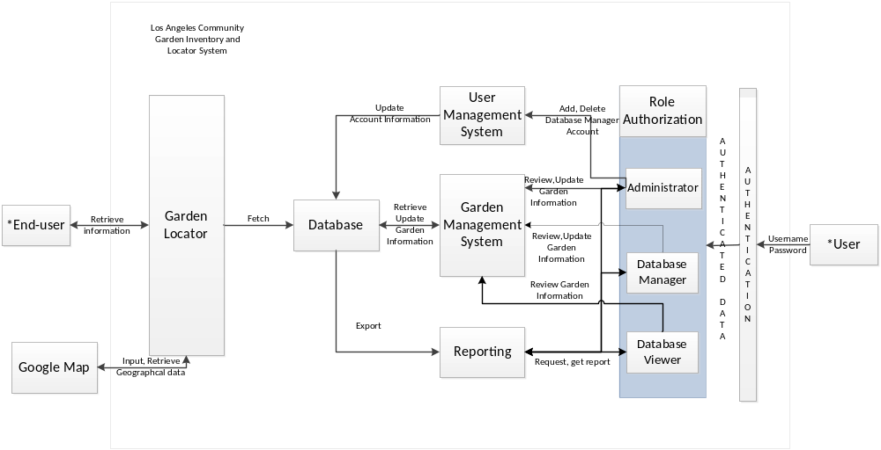*User and End-user are defined in SID section 3, number 11 and 12.
- End-user refers to people who only have access to the external delivery component part of the website to view garden information in limited details
- User refers to people who has access and uses the internal database component part of the website to manage garden information database
Figure 4: Element Relationship Diagram of Los Angeles Community Gardens Inventory and Locator

Business Workflows

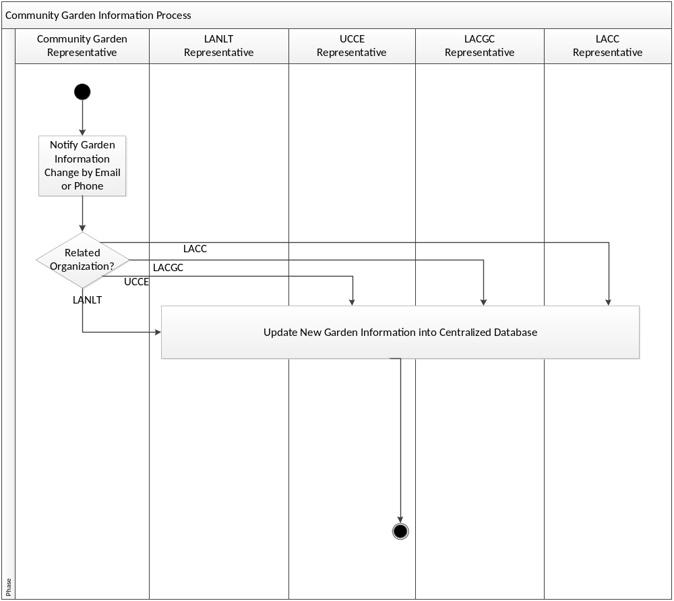
Figure 5: New Business Workflow of Los Angeles Community Gardens Inventory and Locator

Organizational and Operational Implications

Organizational Transformations
- The need of training database managers to have abilities to use and manage data in the new system.
- The elimination of the need to contact different organization in order to obtain information of all community gardens manually.
- The need of organizations that have connection to community gardens to update information through the Los Angeles Community Garden Inventory and Locator system rather than provide the information through particular person.
- The elimination of the need to regularly update document which contains community garden information on LANLT website.
- Administrator will need to manage accounts of database managers.

Operational Transformations
- Database managers will need to update the information of community gardens through new system.
- End-users will have abilities to select and retrieve the information of community gardens with Google map online instead of searching through a full list of community gardens.
- New information will be available to end users as soon as a database manager updates it, rather than having to wait for a new version of the list to be updated.

